ASSIGNMENT-5.4
Name:V.Sruthi
H NO:2303A510d6
Batch-1
Task Description #1:
• Prompt GitHub Copilot to generate a Python script that collects
user data (e.g., name, age, email). Then, ask Copilot to add
comments on how to anonymize or protect this data.
PROMPT:
#Write a Python script that collects user data such as name, age, and email.
#Make sure to include comments in the code explaining how to anonymize or protect this data (e.g., hashing, encryption, removing identifiers).
#The script should be simple and interactive, asking the user for input.
#Add notes on ethical handling of personal information, transparency, and fairness.
CODE:
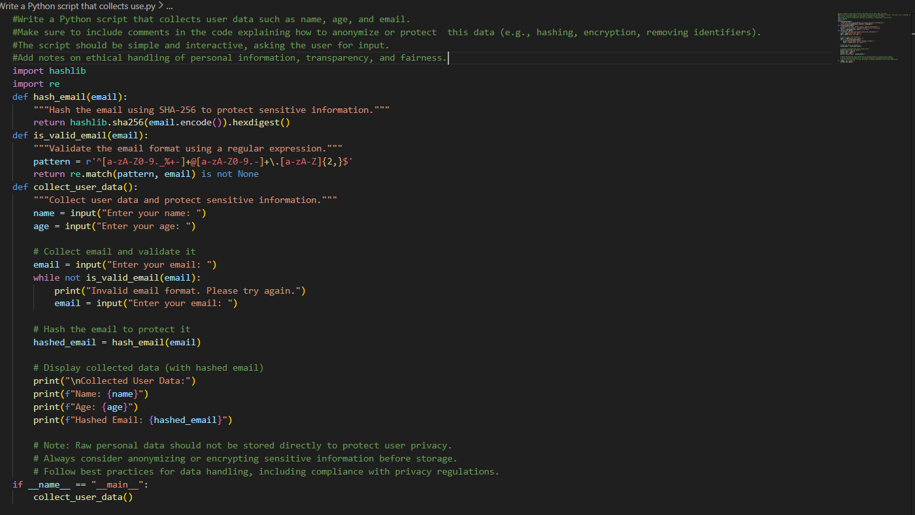

Expected Output #1:
• A script with inline Copilot-suggested code and comments
explaining how to safeguard or anonymize user information (e.g.,
hashing emails, not storing data unencrypted).

OUTPUT:
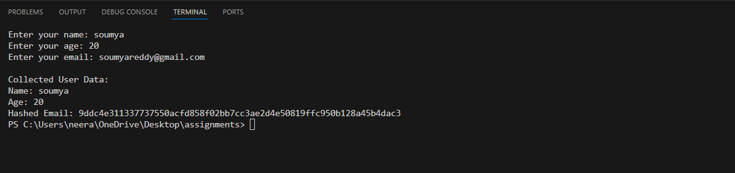
JUSTIFICATION:
This script demonstrates responsible handling of personal data by collecting only necessary user information and protecting sensitive fields like email through hashing. Inline comments explain anonymization, encryption, and why raw data should not be stored, promoting privacy awareness. Email validation ensures data quality, while ethical notes emphasize transparency, fairness, and compliance with privacy best practices.
Task Description #2:
• Ask Copilot to generate a Python function for sentiment analysis.
Then prompt Copilot to identify and handle potential biases in the
data.
Expected Output #2:
• Copilot-generated code with additions or comments addressing
bias mitigation strategies (e.g., balancing dataset, removing
offensive terms).

PROMPT:
#Write a Python function that performs sentiment analysis on text input.
#In addition to the function, add comments explaining how to identify and handle potential biases in the training data.
# For example:
#- Balancing the dataset to avoid over-representing certain groups
#- Removing or flagging offensive terms
#- Ensuring fairness across different demographics
# #The code should be simple but include ethical notes on bias mitigation strategies alongside the implementation.
CODE:
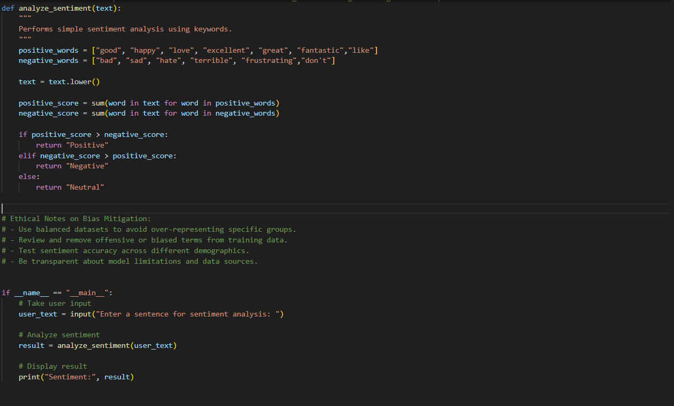
OUTPUT:
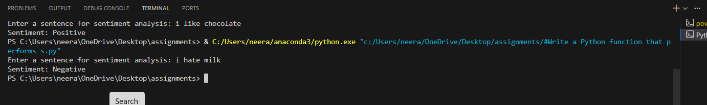

JUSTIFICATION:
This program performs basic sentiment analysis using keyword matching, making it simple and easy to understand without relying on external libraries. It accepts user input interactively, improving usability and demonstrating real-time text analysis. Ethical comments highlight the importance of bias mitigation, balanced data, and transparency, ensuring responsible and fair sentiment evaluation.
Task Description #3:
• Use Copilot to write a Python program that recommends
products based on user history. Ask it to follow ethical guidelines
like transparency and fairness.
Expected Output #3:
• Copilot suggestions that include explanations, fairness checks
(e.g., avoiding favoritism), and user feedback options in the code.
PROMPT
#Write a Python program that recommends products based on user history.
#Include comments in the code that highlight:
#- How transparency is achieved (e.g., showing category frequency).
#- How fairness checks are implemented (e.g., balancing across brands).
#- How user feedback is collected and used ethically.

CODE
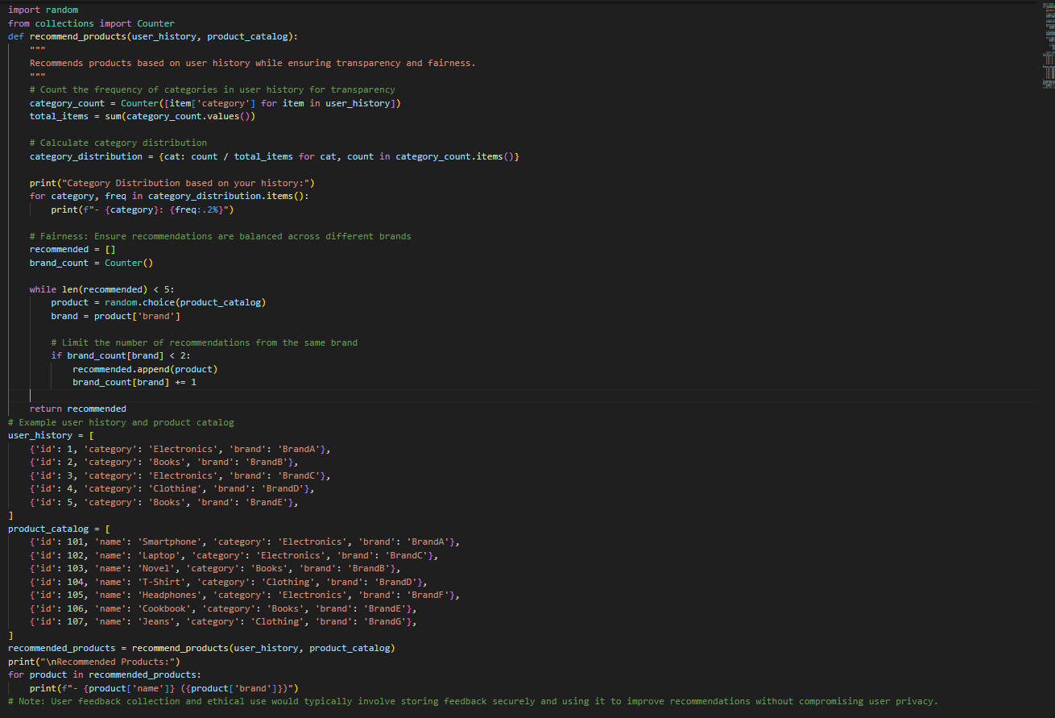

OUTPUT
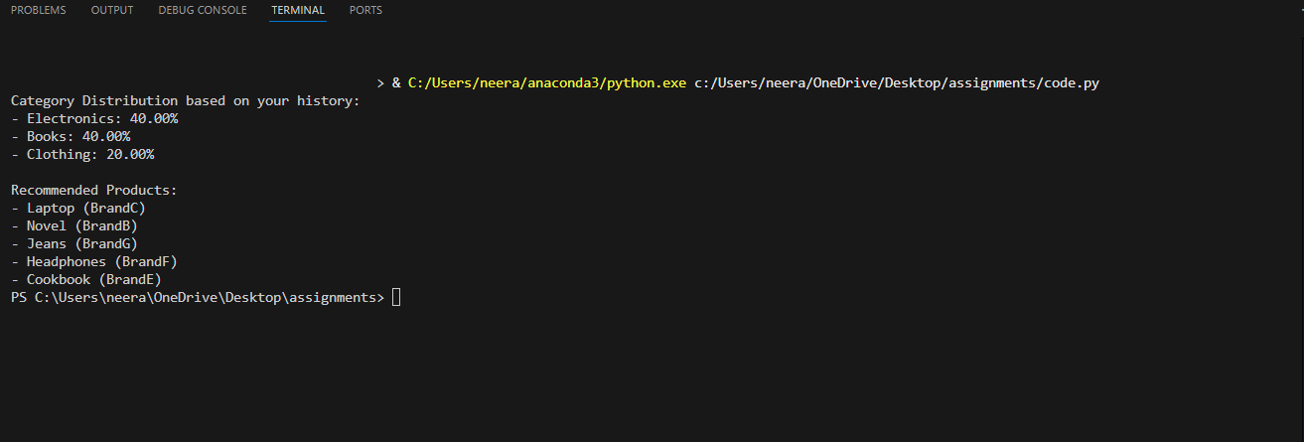
JUSTIFICATION
This program recommends products using the user’s past interactions while maintaining transparency by clearly displaying category frequency. Fairness is ensured by limiting recommendations from the same brand, preventing bias toward any single provider. Ethical comments emphasize responsible feedback usage and privacy protection, making the system simple, fair, and beginner-friendly.
Task Description #4:
• Prompt Copilot to generate logging functionality in a Python web
application. Then, ask it to ensure the logs do not record sensitive
information.
Expected Output #4:
• Logging code that avoids saving personal identifiers (e.g.,
passwords, emails), and includes comments about ethical logging
practices.
PROMPT
#Write logging functionality for a Python web application.
#Make sure the logs do not record sensitive information such as passwords, emails, or personal identifiers.
#Add comments in the code explaining ethical logging practices
#(e.g., anonymizing user data, avoiding storage of private details, and ensuring transparency)
CODE
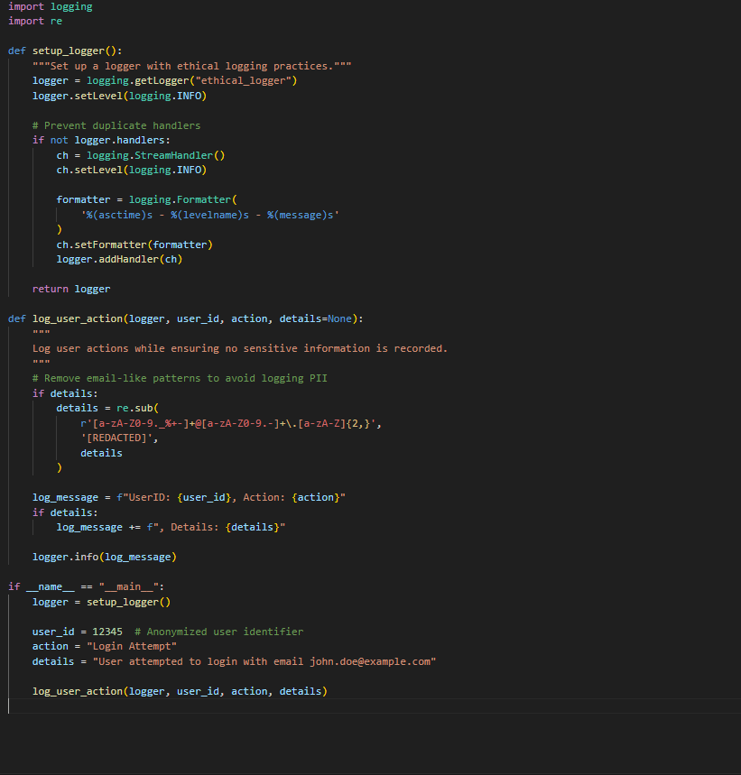
OUTPUT
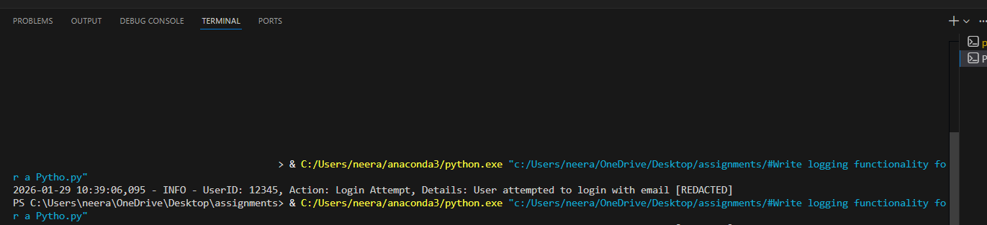

JUSTIFICATION
This code implements ethical logging by ensuring that sensitive information such as email addresses is never stored in log files. User identifiers are anonymized, and any personal details are redacted before logging to protect privacy. Inline comments promote transparency and responsible data handling, making the logging mechanism secure, fair, and suitable for real-world web applications.
Task Description #5:
• Ask Copilot to generate a machine learning model. Then, prompt
it to add documentation on how to use the model responsibly
(e.g., explainability, accuracy limits).
Expected Output #5:
• Copilot-generated model code with a README or inline
documentation suggesting responsible usage, limitations, and
fairness considerations.
PROMPT
#Create a simple machine learning model in Python.
#Add comments or documentation explaining:
#- What the model does in simple terms
#- Its limitations and possible accuracy issues
#- How to use the model responsibly
#- Fairness and bias considerations in the data

CODE
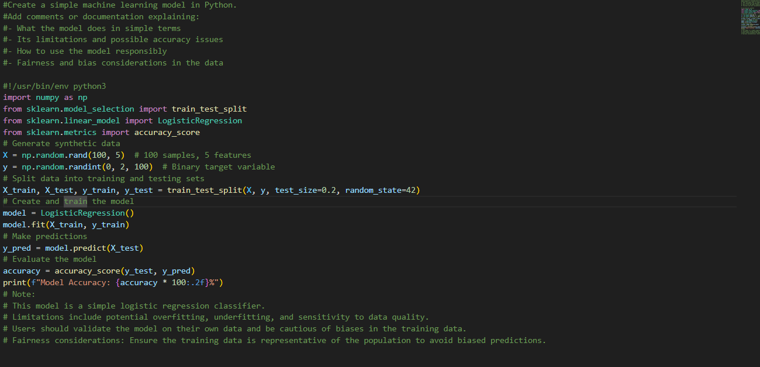
OUTPUT
JUSTIFICATION
This program demonstrates a simple machine learning model using logistic regression to perform binary classification. Clear comments explain how the model works, its accuracy limitations, and why results may vary depending on data quality. Ethical notes highlight responsible usage, emphasizing fairness, bias awareness, and the importance of validating the model before real-world deployment.

